CSA1715-ARTIFICIAL INTELLIGENCE
LAB PROGRAM- 4
21-07-2026
4. Write the python program for Crypt-Arithmetic problem.
Aim
To write a Python program to solve the Crypt-Arithmetic Problem using the Backtracking algorithm.

Algorithm
- Read the given crypt-arithmetic expression.
- Identify all unique letters involved in the expression.
- Assign digits (0–9) to the letters one by one using backtracking.
- Ensure that each letter is assigned a unique digit.
- Do not allow leading letters of any word to be assigned zero.
- After assigning all digits, evaluate the arithmetic expression.
- If the equation is satisfied, display the digit assignment and terminate.
- Otherwise, backtrack and try another digit assignment until a valid solution is found.
Program
from itertools import permutations

letters = "SENDMORY"

for p in permutations(range(10), 8):
d = dict(zip(letters, p))

if d['S'] == 0 or d['M'] == 0:
continue

send = 1000*d['S'] + 100*d['E'] + 10*d['N'] + d['D']
more = 1000*d['M'] + 100*d['O'] + 10*d['R'] + d['E']
money = 10000*d['M'] + 1000*d['O'] + 100*d['N'] + 10*d['E'] + d['Y']

if send + more == money:
print("Solution:")
print("SEND =", send)
print("MORE =", more)
print("MONEY =", money)
break

Output
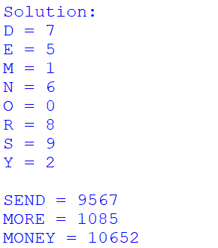

Result:
Thus, the Python program to solve the Crypt-Arithmetic Problem using the Backtracking algorithm was executed successfully.

